Dear Parents and Students,

The information necessary to access your McGraw-Hill online content within ConnectED is found below.

Follow these steps to log in

Go to www.gilmerschools.com
Select Students
Click on ConnectED – Reading Wonders
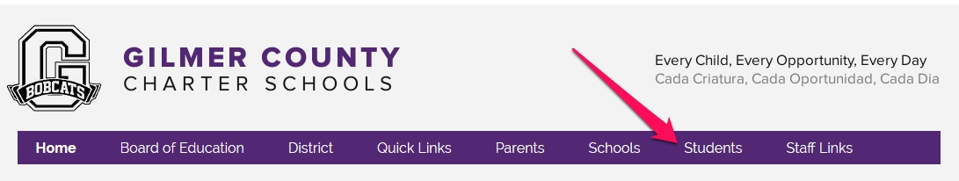

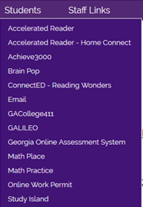

Student Username = First Initial of First Name + Lunch ID
- Example
  - Tara Brown has lunch ID number 52894
  - Her username is
    - T52894
      - Usernames are only case sensitive with Apple products
Password = rw1234

Enter your username and password into the appropriate fields to log into ConnectED

